# Training Plan

1. Complete a Python Course or at least a significant refresh. It is important to know what objects are in Python, the data structures, classes, functions and using techniques such as list comprehension.
2. Complete a course on Docker.
3. Complete a course on Apache Kafka (preferably one which includes creating producers and consumers in Python) – The Complete Apache Kafka Practical Guide on Udemy includes python stuff. Can ignore the Java and Node stuff on it.
4. Read up on Pydantic -> Data validation library.
5. Read up on FastAPI -> API library.
6. Refresh on SQL.

There are plenty of good practical videos on youtube for Pydantic, FastAPI, Kafka.

Project

Your task is to create a python pipeline which utilises all the things you have learned so far. It should do three separate things: Upload data to a Kafka topic, consume from the topic and populate a database, then get the data from the database with an API.

Once completed I will go through your code and ask you to walk through your code with me so you can explain what steps you have taken.

It should include:

* Classes with useful methods and pydantic classes
* An API using FastAPI
* Interacting with Kafka (The Kafka course should show you how to install Kafka on Windows)
* A postgres database with appropriate tables
* A bonus is to create unit tests (For this watch some youtube videos on Pytest – popular Python test library)

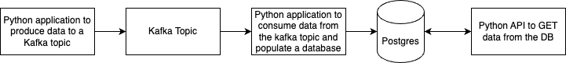For example, in preparation before joining HO, I created a small e-commerce application that was able to create some fake order data in JSON. This data would be sent to a Kafka topic using a python producer. It was consumed in another application and appropriately transformed such that with some SQL was able to populate a database with the data. Then I created a python API using FastAPI where it would GET data from the database again using SQL.